TERM WORK

IV

LIBRARY DATABSE

**Consider the following schema for a Library Database:**

**PUBLISHER (Name, Address, Phone)**

**BOOK (Book_id,Title, Pub_Year, Publisher_Name) BOOK_AUTHORS (Author_Name ,Book_id)**

**LIBRARY_BRANCH (Branch_id, Branch_Name, Address)**

**BOOK_COPIES (No-of_Copies , Book_id, Branch_id)**

**CARD (card_no)**

**BOOK_LENDING (Date_Out, Due_Date ,Book_id, Branch_id, Card_No)**

Write SQL queries to

1. Draw schema and ER diagram for database.
2. Create the above tables by properly specifying the primary keys and foreign keys.
3. Enter at least five tuples for each relation.
4. Retrieve details of all books in the library – id, title, name of publisher, authors, number of copies in each branch,etc.
5. Get the particulars of borrowers who have borrowed more than 3 books, but from Jan 2017 to Jun2017
6. Delete a book in BOOK table. Update the contents of other tables to reflect this data manipulation operation.
7. Partition the BOOK table based on year of publication. Demonstrate its working with a simple query.
8. Create a view of all books and its number of copies that are currently available in the Library.

**1. Schema Diagram**

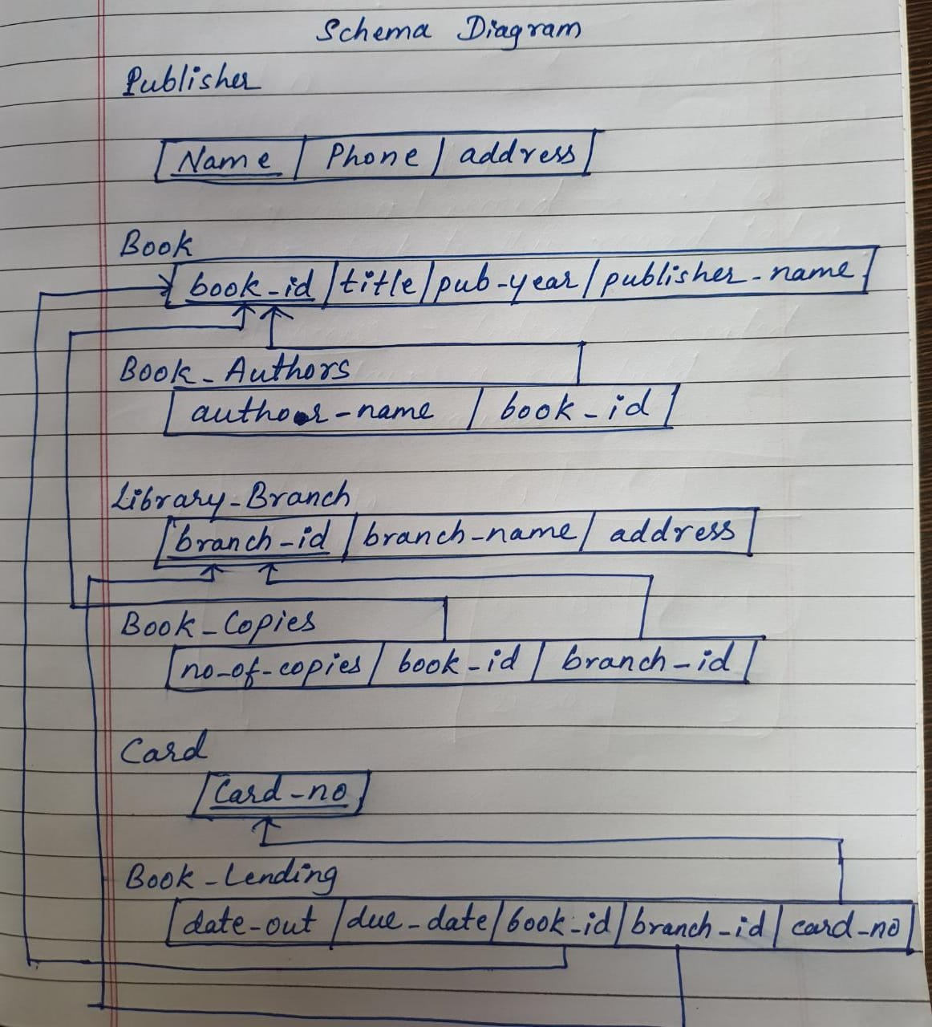

**Entity Relationship Diagram**

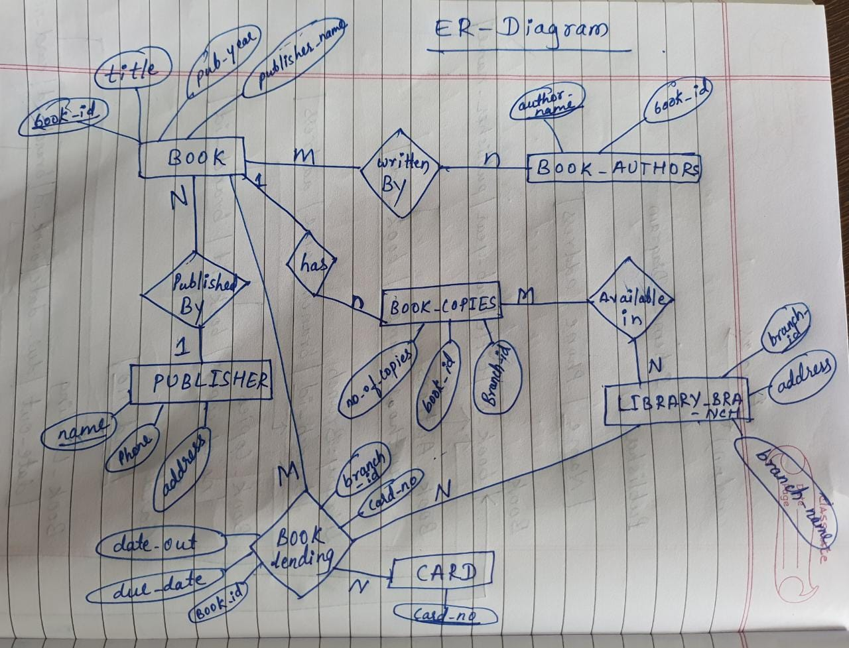

**2. Creation and Description of all tables:**

Create table publisher

(name varchar(20) primary key,

Phone integer,

address varchar (20));

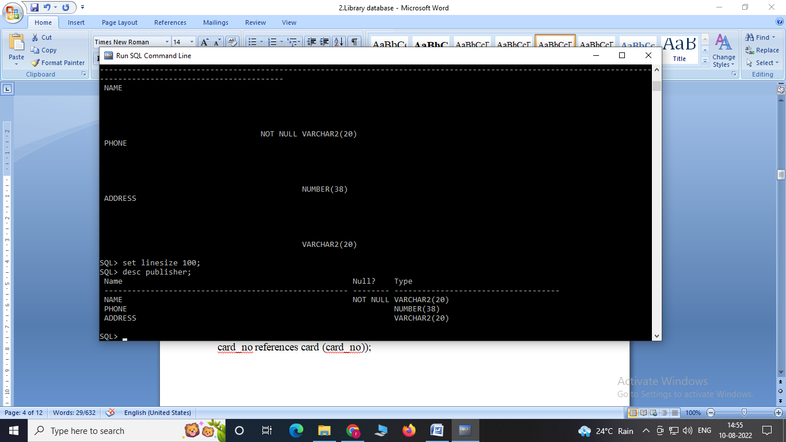

Create table book

(book_id int primary key,

title varchar(20),

Pub_year varchar(20),

Publisher_name references publisher (name)

On delete cascade);

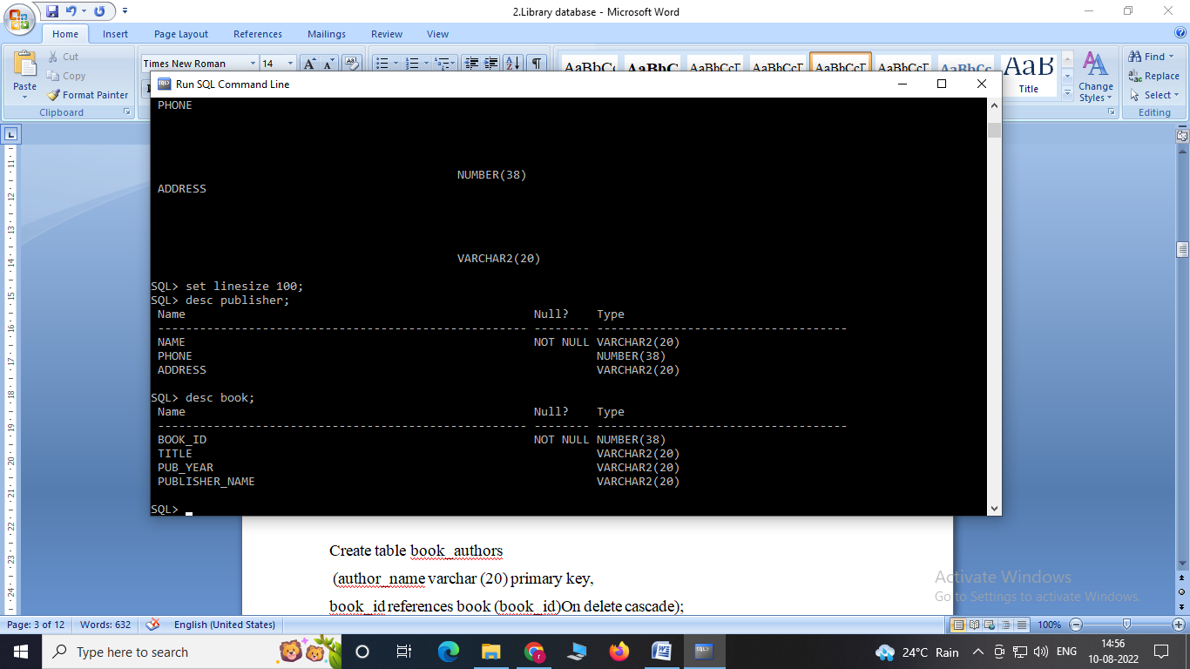

Create table book_authors

(author_name varchar (20) primary key,

book_id references book (book_id)On delete cascade);

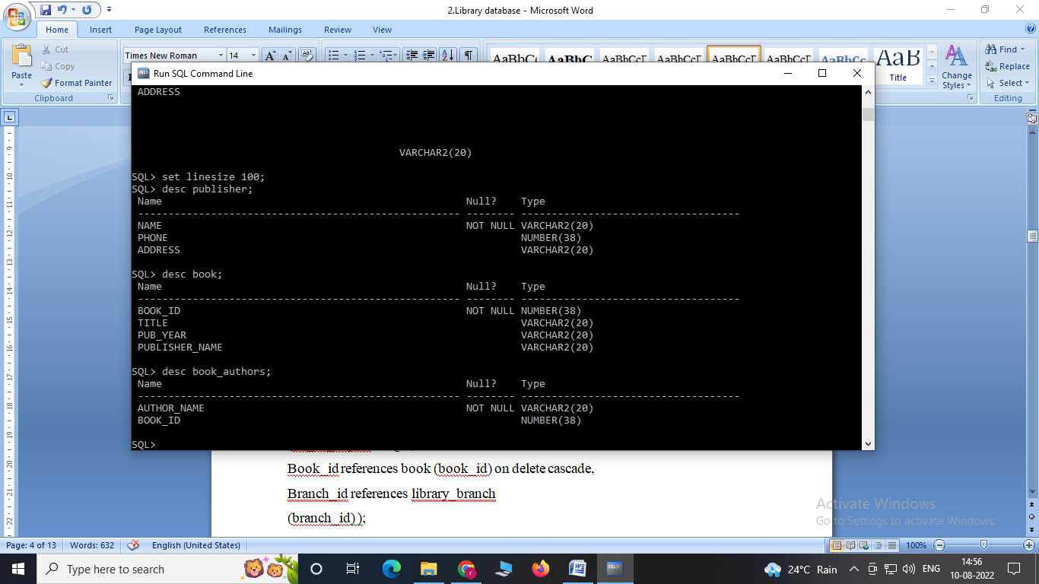

Create table library_branch

(branch_id int primary key,

Branch_name varchar(50),

Address varchar (50));

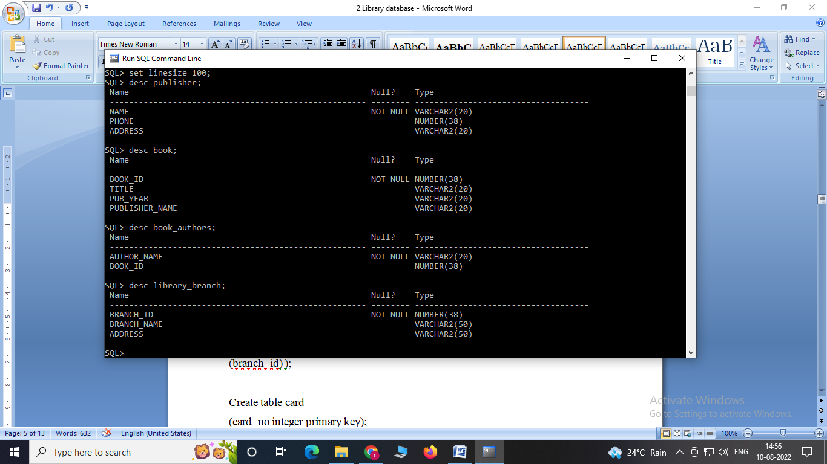

Create table book_copies

(no_of_copies integer,

Book_id references book (book_id) on delete cascade,

Branch_id references library_branch

(branch_id) );

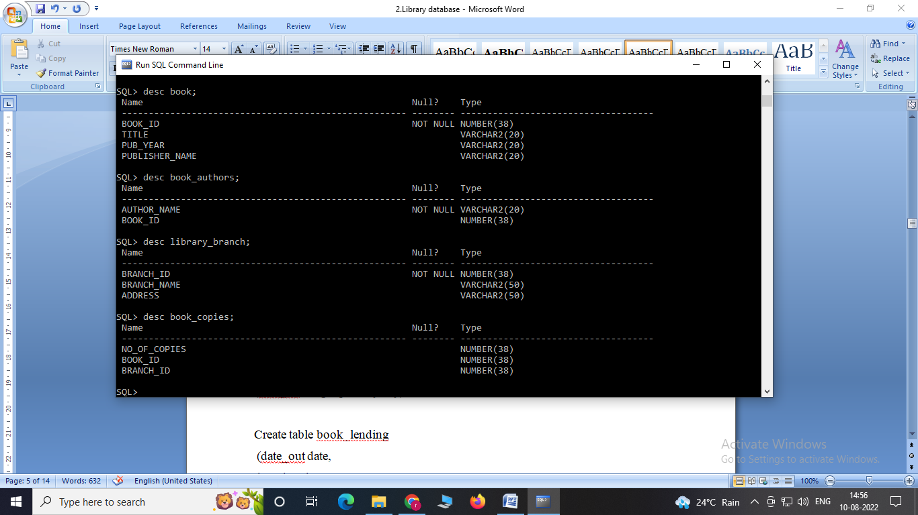

Create table card

(card_no integer primary key);

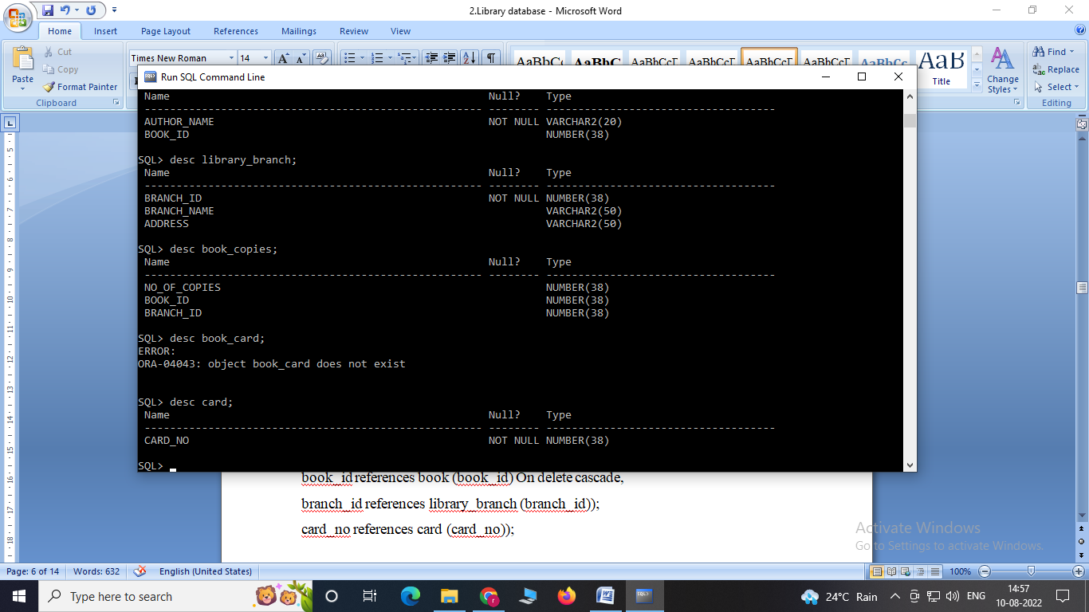

create table book_lending

(date_out date,

due_date date,

book_id references book (book_id) on delete cascade,

branch_id references library_branch(branch_id)on

delete cascade,

card_no references card (card_no) on delete cascade,

primary key (book_id, branch_id, card_no));

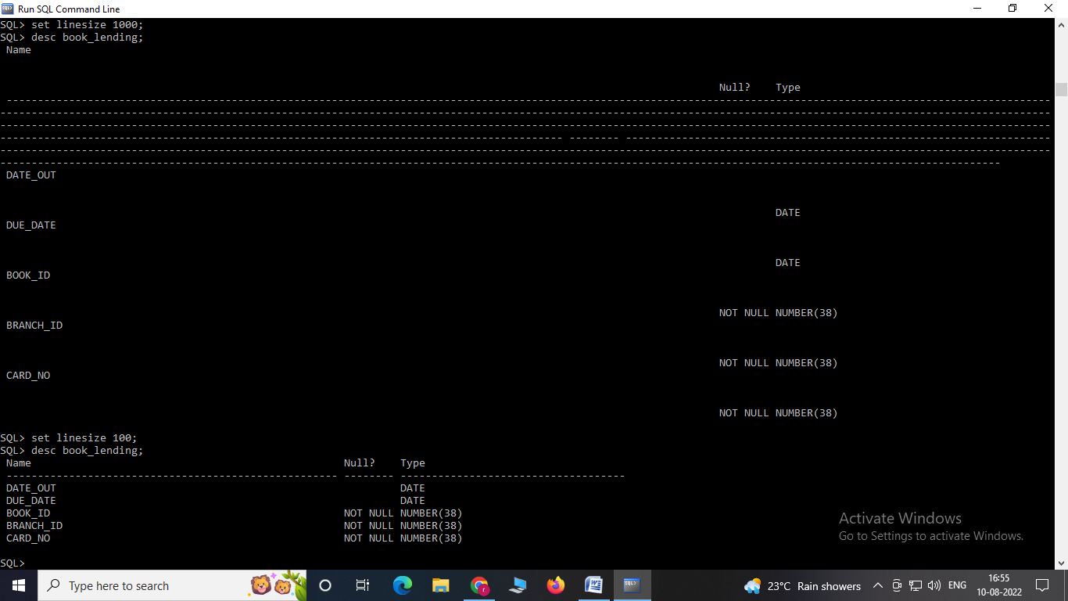

# 3. Insertion of Values to Tables

# PUBLISHER

# insert into publisher values ('mcgraw-hill', 9989076587, 'bangalore');

# insert into publisher values ('pearson', 9889076565, 'newdelhi');

# insert into publisher values ('random house', 7455679345, 'hydrabad');

# insert into publisher values ('oreily', 8970862340, 'chenai');

# insert into publisher values('hachette livre',7756120238,'bangalore');

# 

# BOOK

insert into book values (1,'dbms','jan-2017', 'mcgraw-hill');

insert into book values (2,'dbms','jun-2016', 'mcgraw-hill');

insert into book values (3,'cn','sep-2016', 'pearson');

insert into book values (4,'java','sep-2015', 'oreily');

insert into book values (5,'os','may-2016', 'pearson');

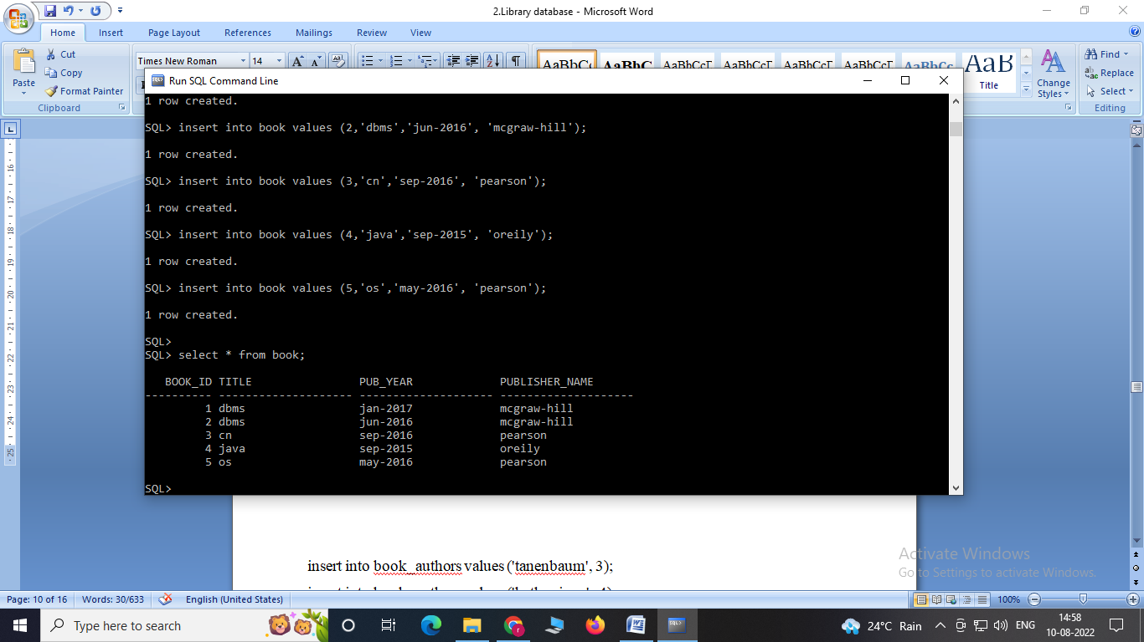

# BOOK_AUTHORS

insert into book_authors values ('navathe', 1);

insert into book_authors values ('kahate', 2);

insert into book_authors values ('tanenbaum', 3);

insert into book_authors values ('kathy sierra', 4);

insert into book_authors values ('galvin', 5);

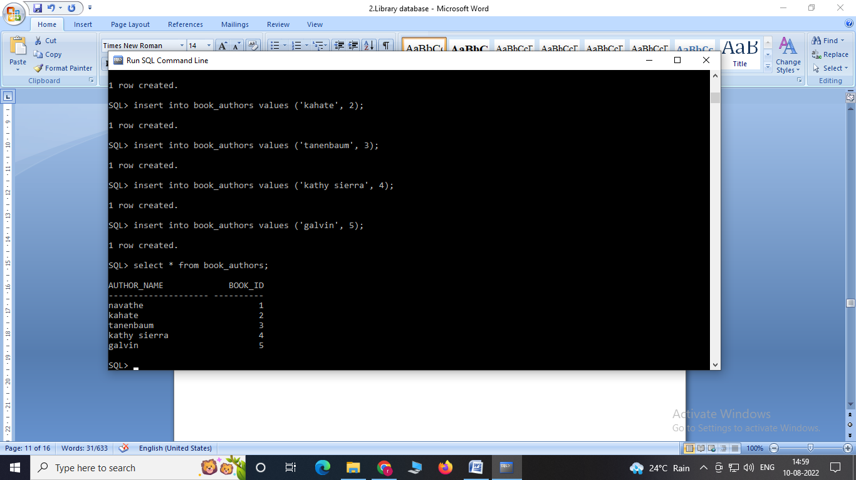

**LIBRARY_BRANCH**

insert into library_branch values (10,'rr nagar','bangalore');

insert into library_branch values (11,'rnsit','bangalore');

insert into library_branch values (12,'rajaji nagar', 'bangalore');

insert into library_branch values (13,'nitte','mangalore');

insert into library_branch values (14,'manipal','udupi');

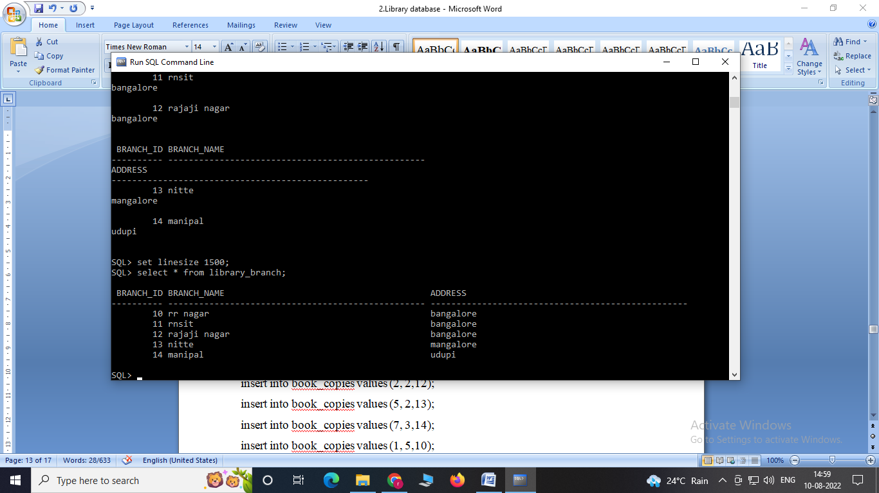

# BOOK_COPIES

# insert into book_copies values (10, 1, 10);

# insert into book_copies values (5, 1,11);

# insert into book_copies values (2, 2,12);

# insert into book_copies values (5, 2,13);

# insert into book_copies values (7, 3,14);

# insert into book_copies values (1, 5,10);

# insert into book_copies values (3, 4,11);

# 

# CARD

insert into card values (100);

insert into card values (101);

insert into card values (102);

insert into card values (103);

insert into card values (104);

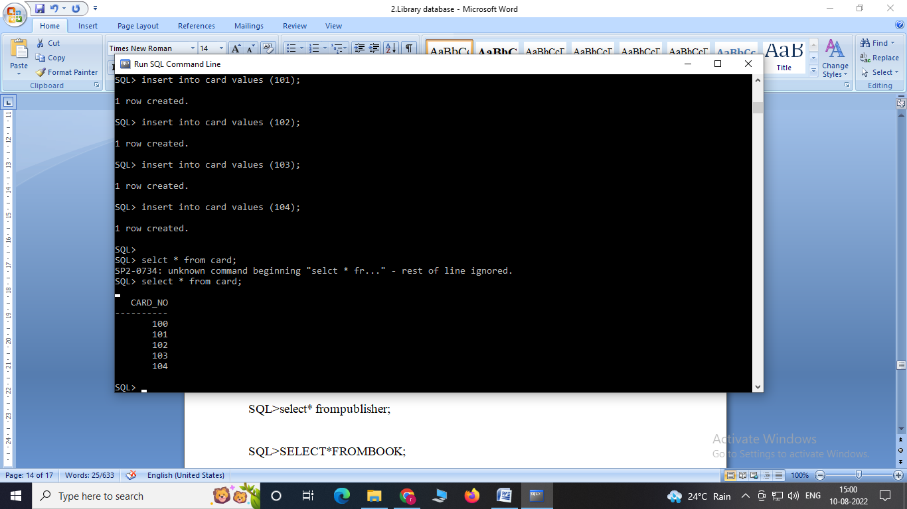

# BOOK_LENDING

insert into book_lending values ('1-jan-17','01-jun-17', 1, 10,101);

insert into book_lending values ('11-jan-17','11-mar-17', 3, 14,102);

insert into book_lending values ('21-feb-17','21-apr-17', 2, 13,101);

insert into book_lending values ('21-jan-17','21-jun-17', 2, 13,101);

insert into book_lending values ('15-jul-17','11-sept-18', 4, 11,104);

insert into book_lending values ('12-apr-17','12-may-17', 1,11,100);

insert into book_lending values ('12-apr-17','12-may-17', 3,13,101);

insert into book_lending values ('12-apr-17','12-may-17', 2,12,101);

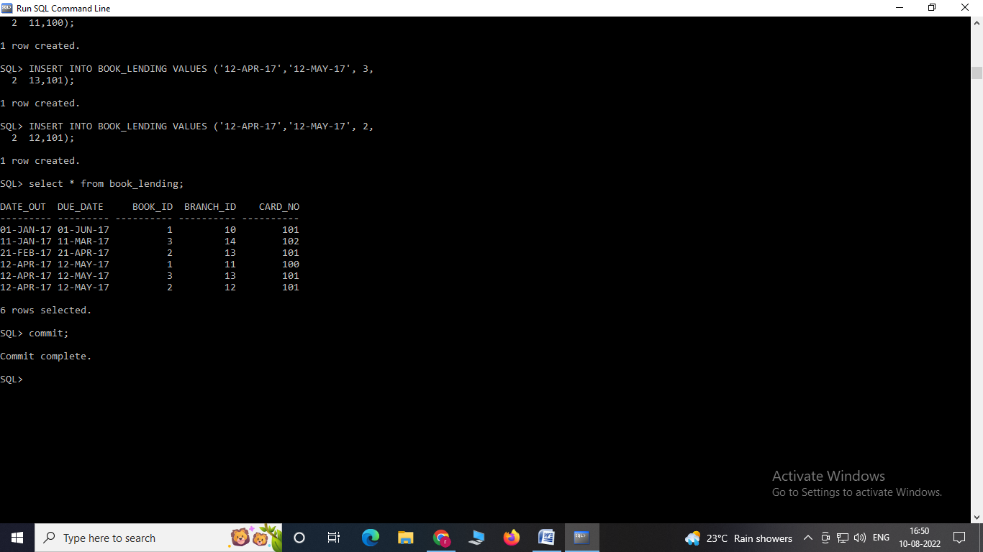

# SQLQueries

**4. Retrieve details of all books in the library – id, title, name of publisher, authors, number of copies in each branch, etc.**

select b.book_id,b.title,b.publisher_name,

a.author_name,c.no_of_copies,l.branch_id

from book b,book_authors a,book_copies c,library_branch l

where b.book_id=a.book_id

and b.book_id=c.book_id

and l.branch_id=c.branch_id;

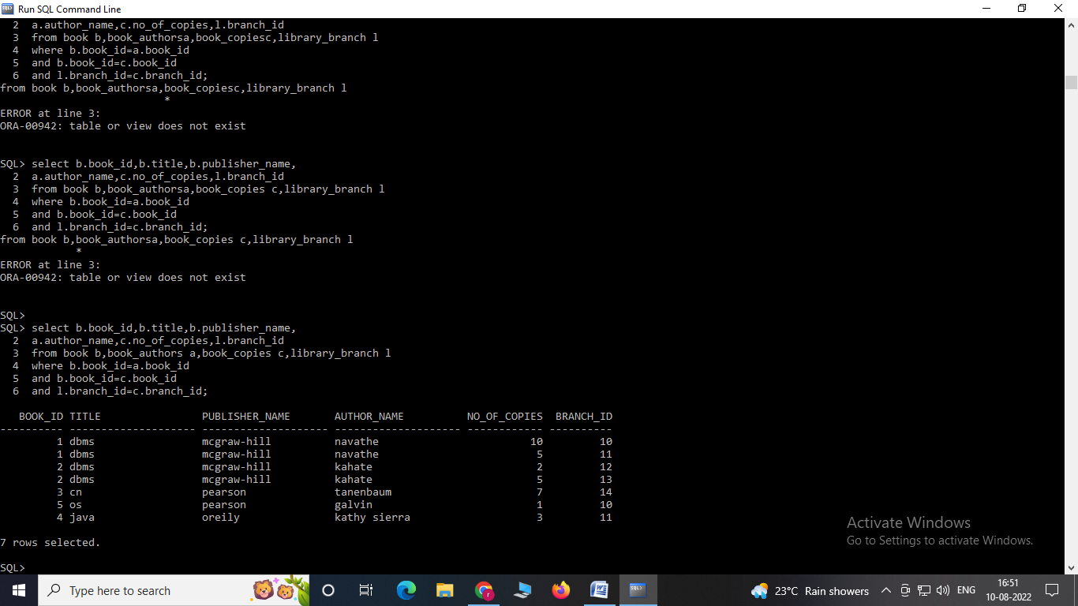

**5. Get the particulars of borrowers who have borrowed more than 3books, but from Jan2017 to Jun2017.**

select card_no from book_lending

where date_out between '01-jan-2017' and '01-Jun-2017’

group by card_no having count(*)>2;

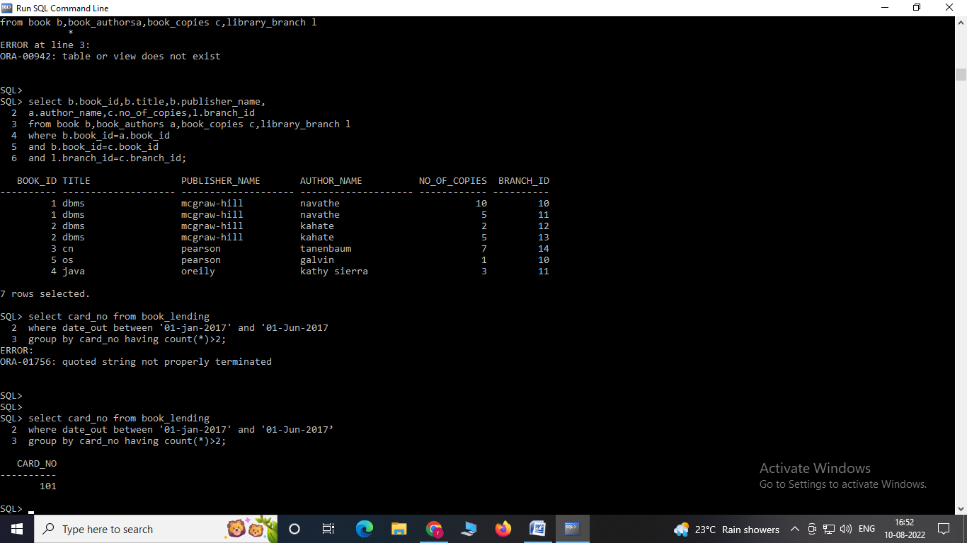

**6. Delete a book in BOOK table. Update the contents of other tables to reflect this data manipulation operation.**

delete from book where book_id=1;

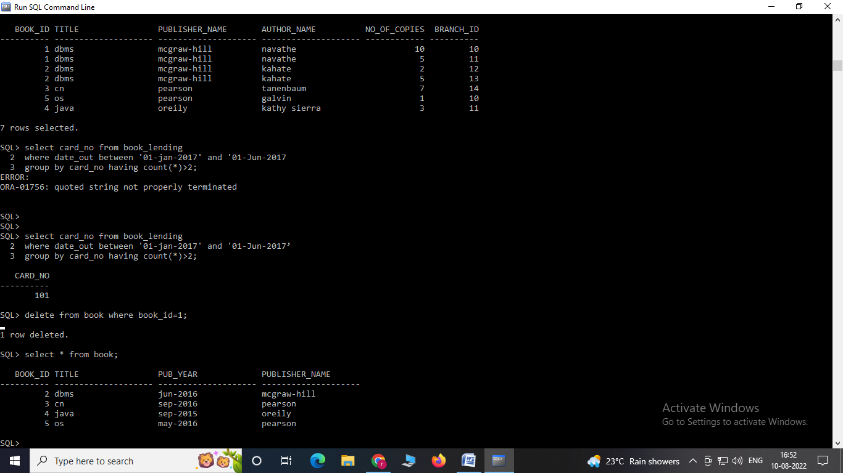

**7. Partition the BOOK table based on year of publication. Demonstrate its working with a simple query**

Create view v_publication as select pub_year from book;

select * from V_Publication;

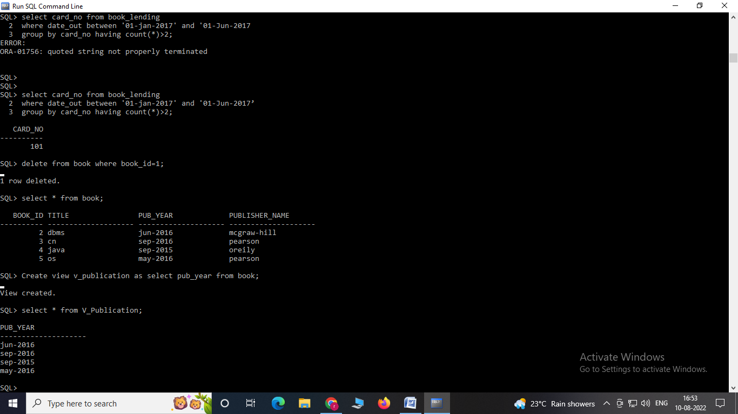

**8. Create a view of all books and its number of copies that are currently available in the Library.**

create view V_BOOKS as

select b.book_id, b.title, c.no_of_copies

from book b, book_copies c, library_branch l

where b.book_id=c.book_id

and c.branch_id = l.branch_id;

select * from V_BOOKS;

